|  |  |
| --- | --- |
| Whitireia Logo_2010 | **Faculty of Information Technology** |

**Bachelor in Information Technology**

**IT7x28 Human Computer Interaction**

HCI Prototype Final

Table of Contents

[Problem 3](#_Toc517469636)

[Observations and Interviews 3](#_Toc517469637)

[Questionnaire 1 3](#_Toc517469638)

[Questionnaire 2 4](#_Toc517469639)

[Questionnaire 3 4](#_Toc517469640)

[Questionnaire 4 5](#_Toc517469641)

[User Group, Profiles and Usability Goals 5](#_Toc517469642)

[Usability Goals 5](#_Toc517469643)

[User Profiles 6](#_Toc517469644)

[User Profile 1 6](#_Toc517469645)

[User Profile 2 6](#_Toc517469646)

[Background Research 7](#_Toc517469647)

[App 1 7](#_Toc517469648)

[App 2 8](#_Toc517469649)

[App 3 9](#_Toc517469650)

[Prototype Design 10](#_Toc517469651)

[Prototype 1 Design 10](#_Toc517469652)

[Prototype 2 Design 11](#_Toc517469653)

[Resolved Prototype Design 12](#_Toc517469654)

[Evaluation Criteria 13](#_Toc517469655)

[Prototype 1 Criteria 13](#_Toc517469656)

[Prototype 2 Criteria 15](#_Toc517469657)

[Prototype Testing 17](#_Toc517469658)

[Prototype 1 Testing 17](#_Toc517469659)

[Prototype 2 Testing 17](#_Toc517469660)

[Development Plan 18](#_Toc517469661)

[References 19](#_Toc517469662)

# Problem

One of the main issues with my Organizational Planner is that design is lacklustre. Other issues that came up during testing were about the lack of features. Suggested features for improving the application involved reminders and a calendar for items, a way to prioritise items, and sharing lists with other people.

# Observations and Interviews

## Questionnaire 1

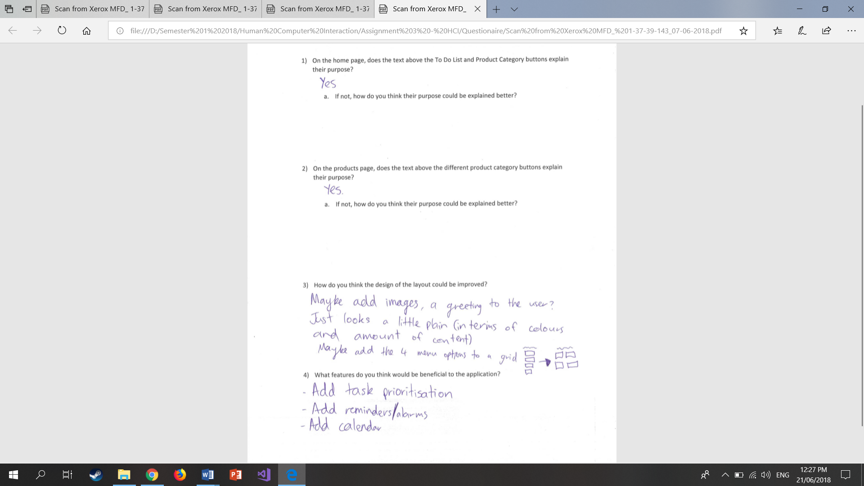

## Questionnaire 2

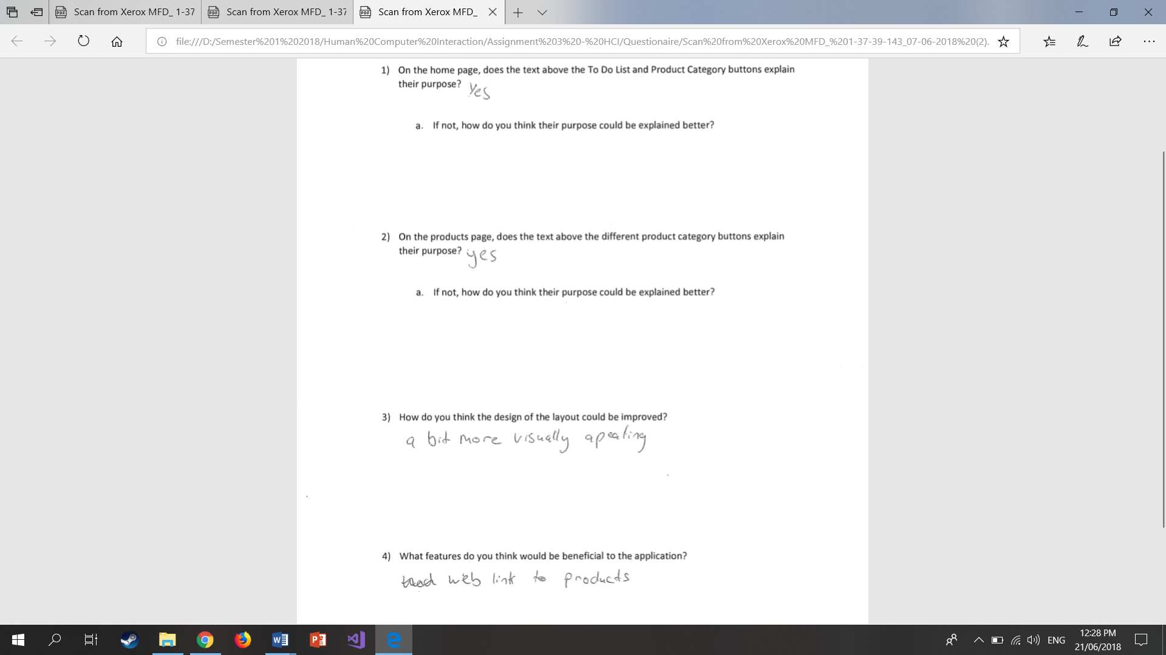

## Questionnaire 3

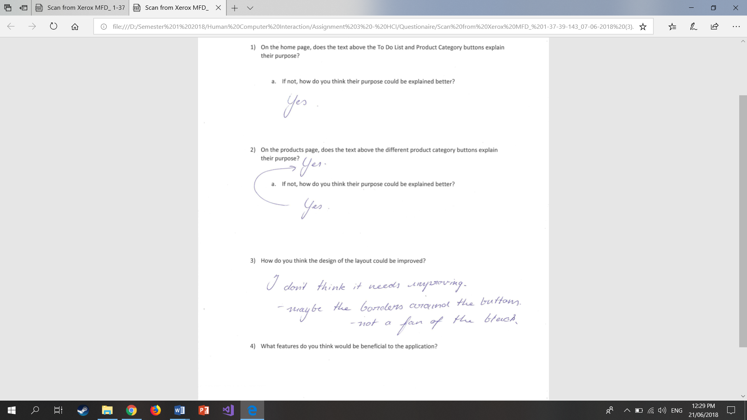

## Questionnaire 4

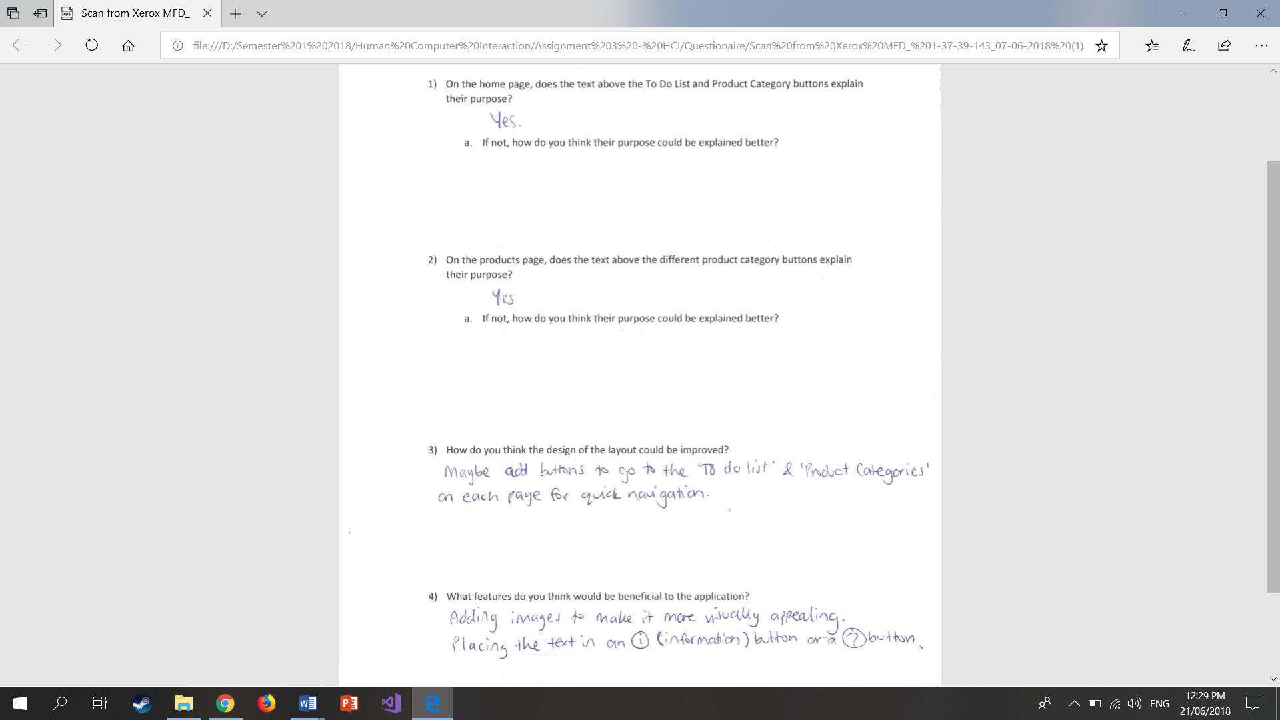

# User Group, Profiles and Usability Goals

## Usability Goals

* Available on all smart phone devices
* Understand how to navigate between pages
* Understand what each of the lists are used for
* Add item to lists
* Delete specific item from lists
* Favourite specific item
* Set a date/time reminder for a specific item
* Improve productivity at home

## User Profiles

### User Profile 1

Name: Kevin O’Conner

Age: 21

Occupation: Student at Massey University

Location: Wellington

Problem: Kevin lives with two other flatmates and so they are looking for a way to divide the chores and grocery shopping. With the organisational planner app Kevin and his flatmates will be able to create a list of chores that they can split up for each flatmate, they can also set lists for all of the products they will need around the house and this will help them with figuring out the costs of the products and who will need to get what.

### User Profile 2

Name: Charlotte Hyland

Age: 34

Occupation: IT Project Manager

Location: Auckland

Problem: Charlotte lives with her husband in their house in Auckland. Using the organisational planner app they are able to set a list of chores for both of them, with Charlotte’s chores being inside house and her husbands chores for outside, and they are able to favourite which chores are the most important as they are busy people. They set reminders for which products to get on which day such as only necessary ingredients for dinner.

# Background Research

## App 1

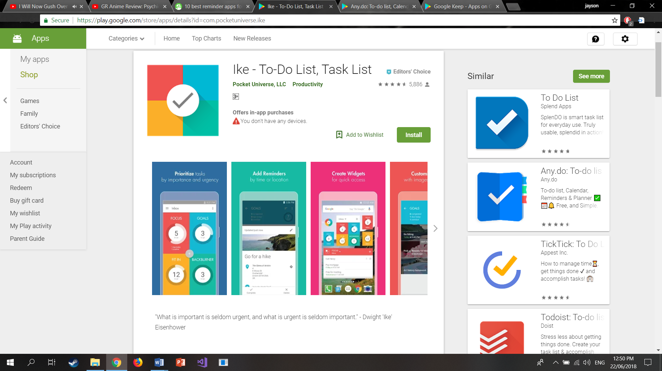

IKE reminder app that focuses on prioritising tasks depending of there importance when first created. Tasks can have reminders based on time or location, and images and audio recoding can be used to further personalize each task.

Having an image represent a specific task would be useful for my prototype due to the five different lists, this was also a suggestion on the evaluation criteria of my first prototype. On the main page of IKE it shows how many tasks are contained within each list, which could be useful for each of my list categories.

## App 2

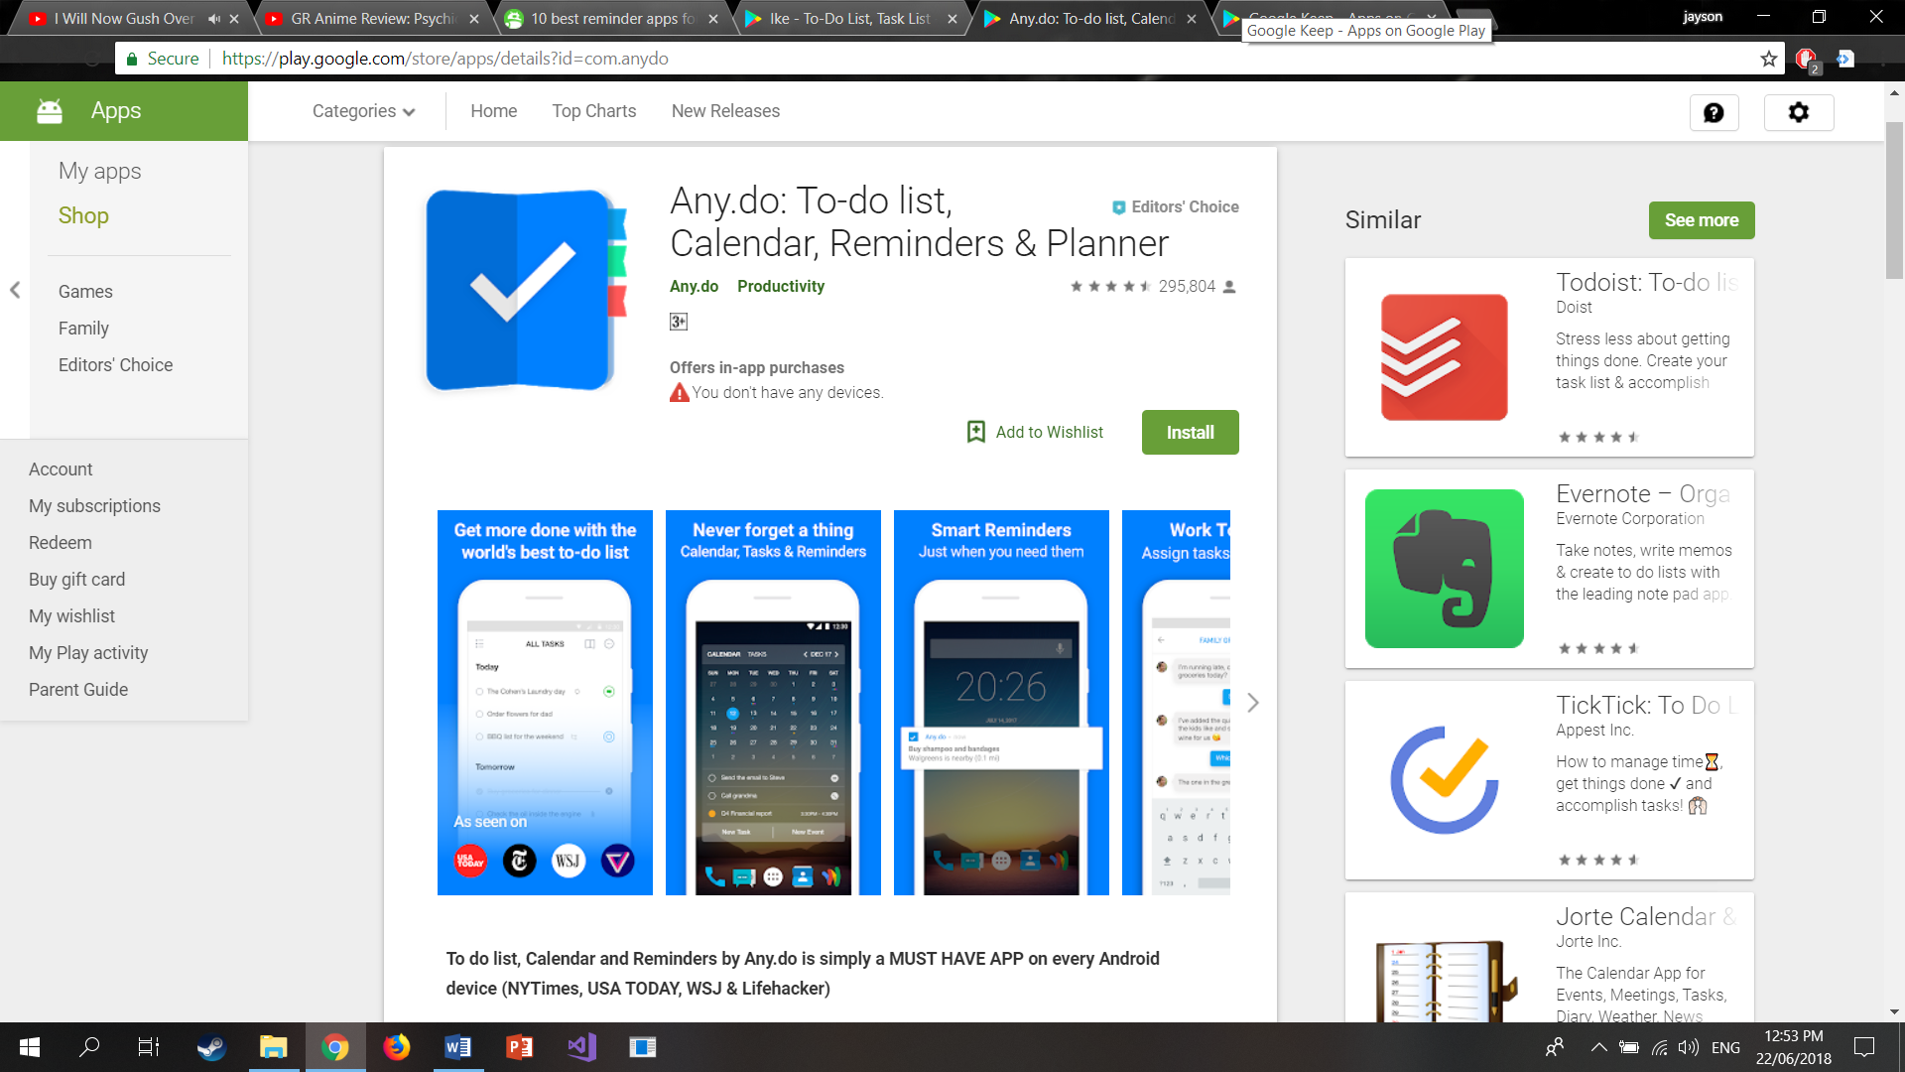

Any.do is a reminder app that allows for seamless synching between all versions of the app, the ability to share lists with people and tasks can be added from your email, files from cloud storages can be attached to a task and can link with various calendars. There is also a speech function that allows the user to add tasks through their voice.

A share function was added to my second prototype, but I did not think to add a function to specifically assign tasks for other people.

## App 3

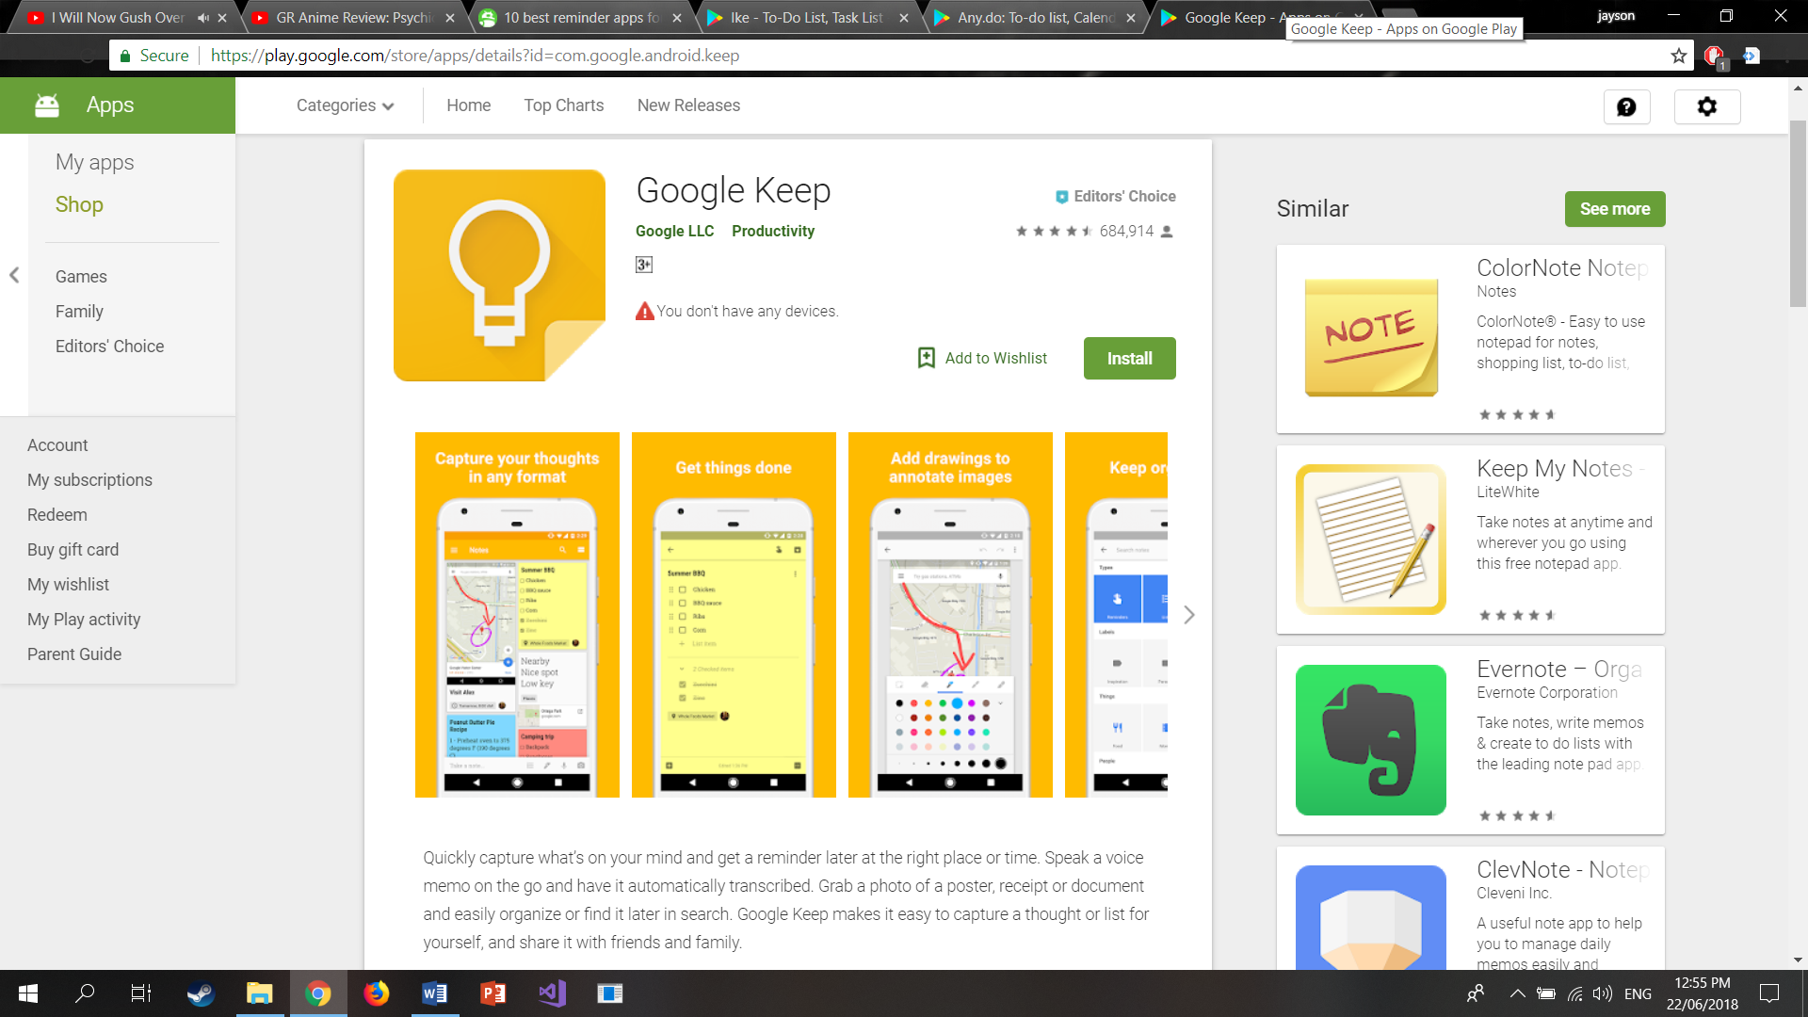

Google Keep is a reminder app that allows the user to add tasks through a speech function, tasks can be added using auto search, add photos and organise them, add colour and labels to tasks for easier identification and draw on images such as a map for annotation. All the tasks and images can be shared.

# Prototype Design

## Prototype 1 Design

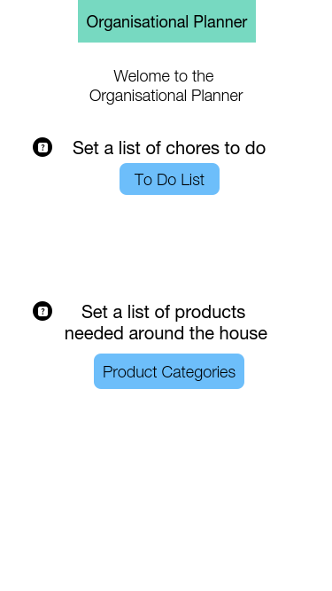 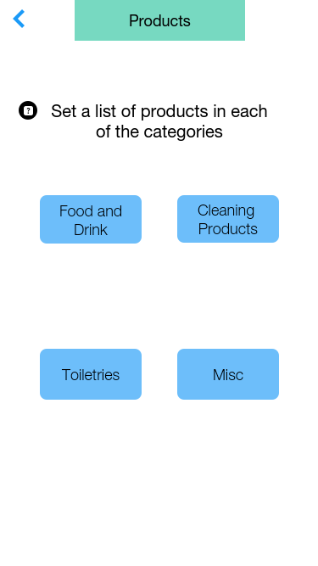 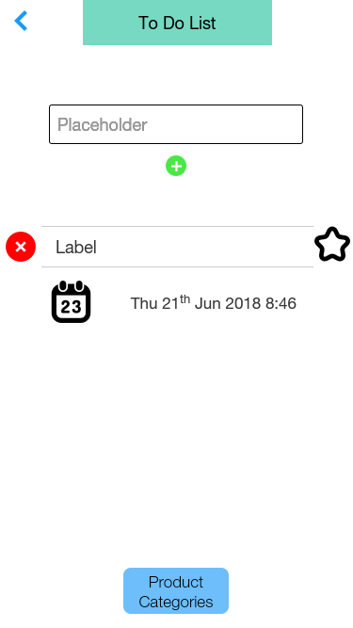

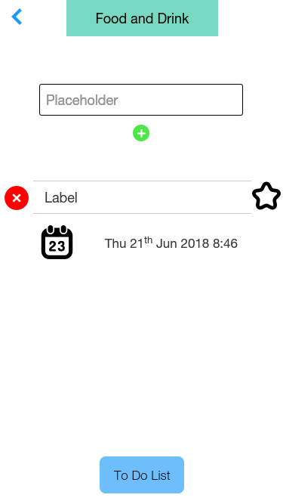 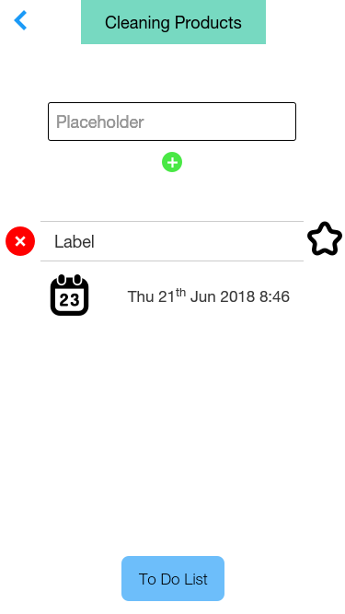 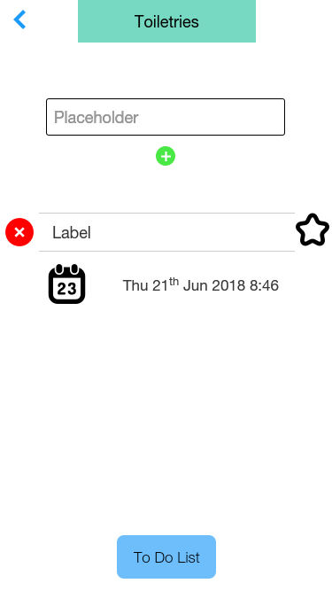

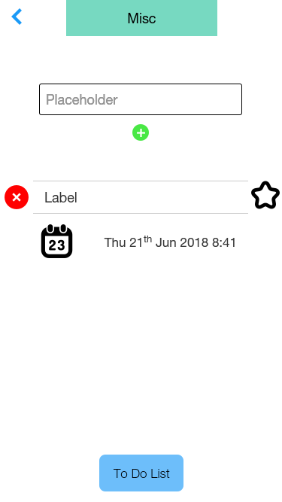

## Prototype 2 Design

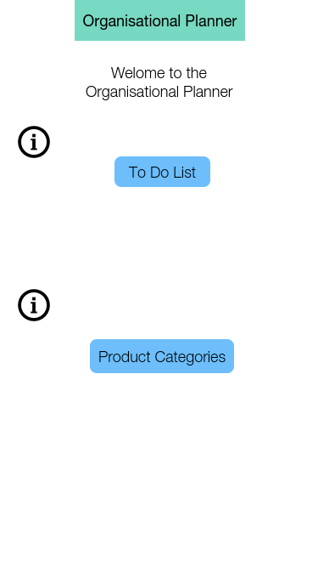 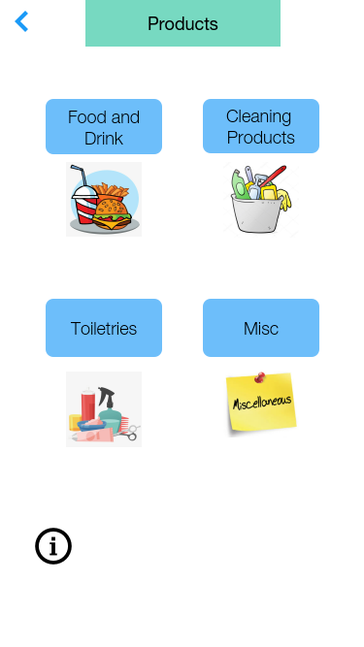 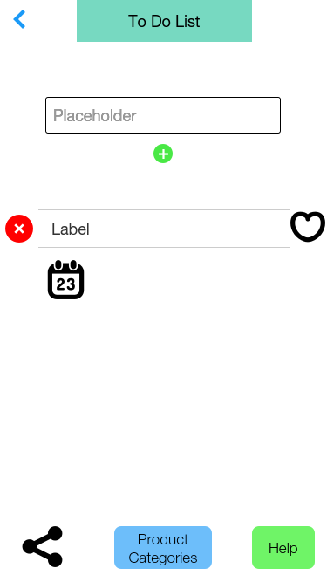

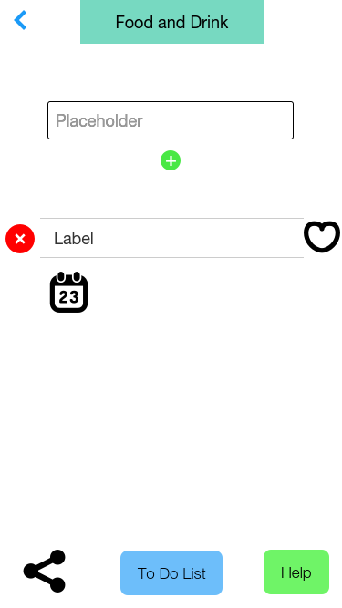 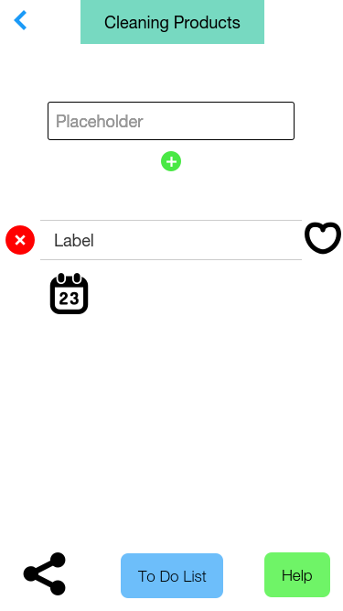 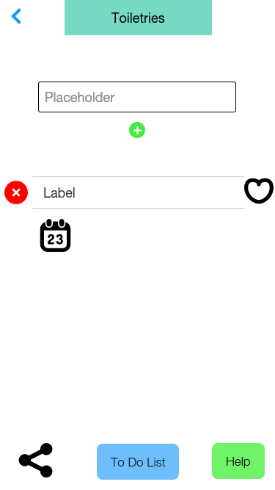

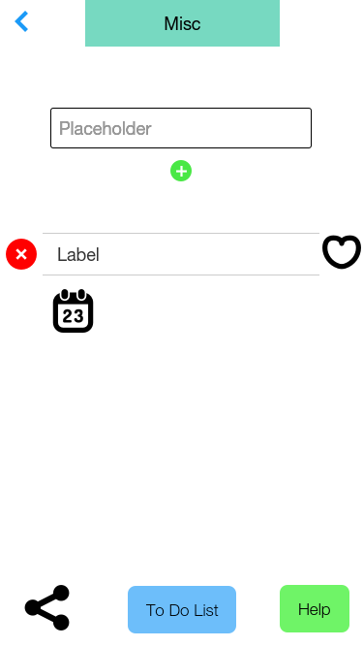 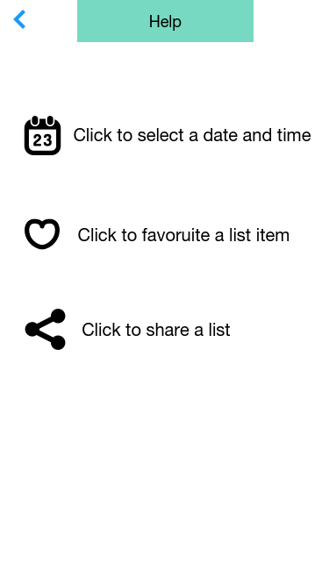

## Resolved Prototype Design

  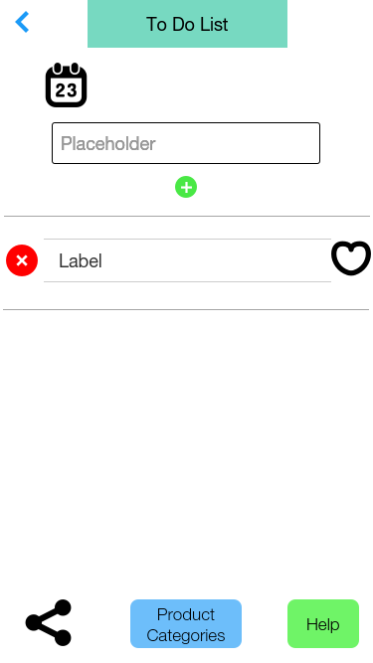 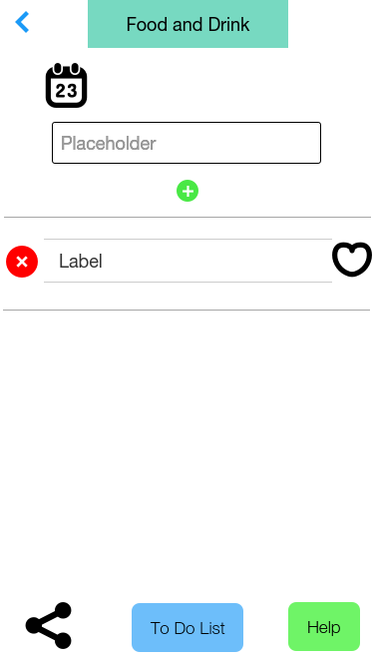 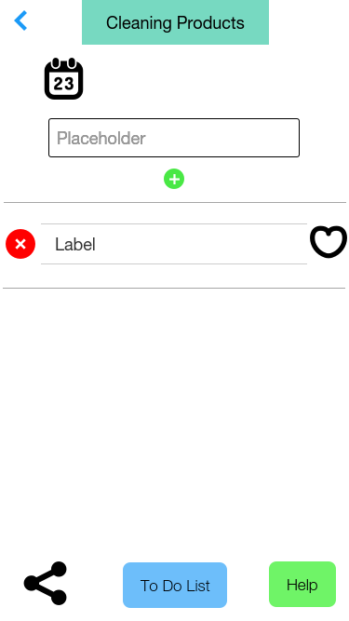 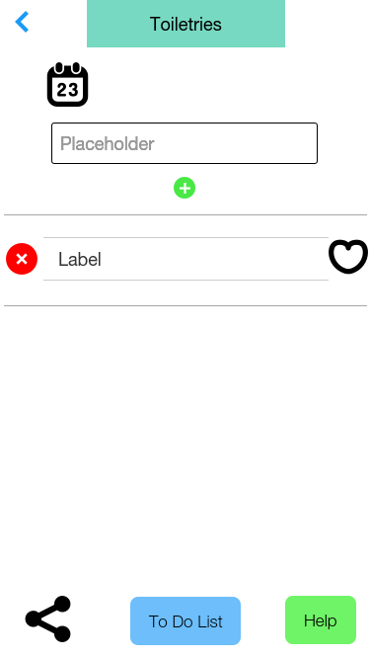 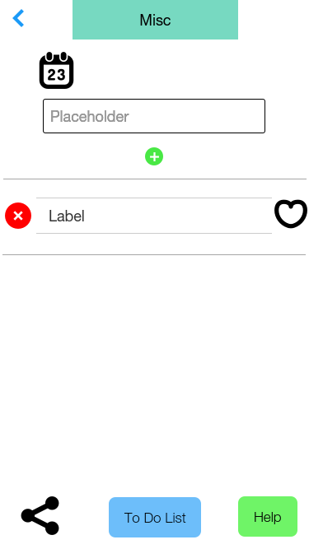 

# Evaluation Criteria

## Prototype 1 Criteria

HCI Prototype Criteria

5 = Strongly Agree

3 = Neutral

1 = Strongly Disagree

|  |  |  |  |  |  |
| --- | --- | --- | --- | --- | --- |
| **Question** | **1** | **2** | **3** | **4** | **5** |
| Navigating the app is simple and easy? |  |  |  |  | X |
|  | | | | | |
| The purpose of the app is understandable? |  |  |  |  | X |
|  | | | | | |
| The functions of the app are easy to learn? |  |  |  | X |  |
|  | | | | | |
| The design of the interface is clear? |  |  |  |  | X |
|  | | | | | |
| I can become more productive using this system? |  |  |  |  | X |
|  | | | | | |
| I was stuck or unsure while using the app? |  |  | X |  |  |
|  | | | | | |
| The purpose of the buttons surrounding the list item are understandable? |  |  | X |  |  |
|  | | | | | |
| I am satisfied with this system |  |  |  | X |  |

|  |
| --- |
| **Comments**  **(any issues or ways to improve the app)** |
| You could put the help buttons inside a separate help/tutorial menu as the repeated use of them makes the interface look a little cluttered. If kept as is, they could be a different design because the question mark symbol is very small and isn’t easily seen. Or they could be put as a subtitle in smaller text. Some more images or icons would be nice just to fill up the screen and add more visuals. It wasn’t immediately clear what the star and calendar + date were meant to mean but I figured it out soon enough. The cross in a red circle was clear to me as a delete button but then the tick at the end of the item confused me so you could use maybe a different icon that showed it’s a checked box. Instead of “placeholder” for the placeholder text, you could have an example item to prompt the user. The rest of the interface were pleasing though and there weren’t any glaring issues that would make me be annoyed with the application. |

|  |  |  |  |  |  |
| --- | --- | --- | --- | --- | --- |
| **Question** | **1** | **2** | **3** | **4** | **5** |
| Navigating the app is simple and easy? |  |  |  |  | X |
|  | | | | | |
| The purpose of the app is understandable? |  |  |  |  | X |
|  | | | | | |
| The functions of the app are easy to learn? |  |  |  | X |  |
|  | | | | | |
| The design of the interface is clear? |  |  |  | X |  |
|  | | | | | |
| I can become more productive using this system? |  |  |  |  | X |
|  | | | | | |
| I was stuck or unsure while using the app? |  |  |  | X |  |
|  | | | | | |
| The purpose of the buttons surrounding the list item are understandable? |  |  | X |  |  |
|  | | | | | |
| I am satisfied with this system |  |  |  | X |  |

|  |
| --- |
| **Comments**  **(any issues or ways to improve the app)** |
| The interface was simple and easy to understand. I would suggest adding some images to make it more appealing. In terms of functionality, it was clear what the application is for. The calendar symbol/function’s purpose was a little confusing to me and it wasn’t too clear that you had to check off a list item before deleting it (I assume that’s what users are meant to do?). Other than that, maybe adding functionalities like sharing the list with others or adding your own images to lists (for memory purposes of specific items) would be really cool. |

## Prototype 2 Criteria

|  |  |  |  |  |  |
| --- | --- | --- | --- | --- | --- |
| **Question** | **1** | **2** | **3** | **4** | **5** |
| Navigating the app is simple and easy? |  |  |  |  | X |
|  | | | | | |
| The purpose of the app is understandable? |  |  |  |  | X |
|  | | | | | |
| The functions of the app are easy to learn? |  |  |  |  | X |
|  | | | | | |
| The design of the interface is clear? |  |  |  |  | X |
|  | | | | | |
| I can become more productive using this system? |  |  |  |  | X |
|  | | | | | |
| I was stuck or unsure while using the app? | X |  |  |  |  |
|  | | | | | |
| The purpose of the buttons surrounding the list item are understandable? |  |  |  | X |  |
|  | | | | | |
| I am satisfied with this system |  |  |  |  | X |

|  |
| --- |
| **Comments**  **(any issues or ways to improve the app)** |
| Possibly move the calendar icon to the top (above the textbox) so that users can change the date before adding an item to the list. |

|  |  |  |  |  |  |
| --- | --- | --- | --- | --- | --- |
| **Question** | **1** | **2** | **3** | **4** | **5** |
| Navigating the app is simple and easy? |  |  |  |  | X |
|  | | | | | |
| The purpose of the app is understandable? |  |  |  |  | X |
|  | | | | | |
| The functions of the app are easy to learn? |  |  |  |  | X |
|  | | | | | |
| The design of the interface is clear? |  |  |  |  | X |
|  | | | | | |
| I can become more productive using this system? |  |  |  |  | X |
|  | | | | | |
| I was stuck or unsure while using the app? | X |  |  |  |  |
|  | | | | | |
| The purpose of the buttons surrounding the list item are understandable? |  |  |  |  | X |
|  | | | | | |
| I am satisfied with this system |  |  |  |  | X |

|  |
| --- |
| **Comments**  **(any issues or ways to improve the app)** |
| Everything is a lot nicer than the previous iteration and the use of colours for the help button and the delete button is very handy. I like that with the two main sections of the app (to do list and product categories), it’s much easier and practical to flip between the two instead of some kind of menu or navigation bar. It makes for a cleaner and more easy to understand structure and I don’t feel like I’m not able to find something. The only issue would be that the images for the product categories aren’t clickable, only the text button above them are. It would make more sense to have them also working as buttons so you could maybe make them as the same element? |

# Prototype Testing

My free trial for JustInMind Prototyper expired while working on this assignment and so I used Proto.io instead. Some of the functions for the prototype were not able to be replicated with Proto.io, this includes not be able to add subsequent items to a list.

## Prototype 1 Testing

The questionnaire that was handed to the testers that was used find ways to improve upon my final prototype from the second assignment. The first and second questions asked if the text above the to do list button and product category button explained what their purpose was. Each tester stated that the text did explain the purpose and so they were used in Prototype 1. However, one of the testers proposed that the text could be used with an information button and so the text was made invisible to the user unless they click on the information button.

A way of improving the layout that was proposed was to add to do list and product category buttons to each of the pages for easier navigation. I added a product category button to the to do list page, and a to do list button to the food and drink, cleaning product, toiletries, and misc pages.

Other ways of improving the layout that were proposed, was to add a greeting, which was added on the home page and to change the four product category buttons on the product category page into a grid instead of a line.

Two features that were proposed was to add was task prioritisation and a calendar. Task prioritisation was added as an empty star symbol that when clicked is meant to fill, indicating that the list item is favoured. The calendar was added as a calendar button that when clicked shows the date time which is meant to allow the user to select a date for each list item. Lastly, it was proposed that the black borders of the buttons be removed, which was done.

## Prototype 2 Testing

Evaluation criteria was handed to the testers to evaluate my first prototype. One of the biggest issues with the prototype was a lack of images and so I added four images on the product category page corresponding to each of the four product categories. Another issue concerned the favourite button and calendar button and a suggestion was to add a help page. I added the help page with easy access on each of the to do list and product category pages. The favourite button represented by a star was replaced with a heart symbol for better understanding and the help page contains the calendar, favourite, and share buttons with a description. The information button was not easy to see for the testers, so I changed it into a larger and easier to make out image.

A checkbox function was added to the first prototype allowing the user to check off a list item, however the testers were confused by it, so I removed it. A sharing function was also suggested and so I added a share button for each of the to do list and product category pages, so the user can share a list.

# Development Plan

For my prototype testing, instead of creating three prototypes which would be tested together, I created my first prototype had testers use my organisational planner with evaluation criteria then I would improve upon the app from the given feedback. I did this again for the second prototype and used that feedback in creating my resolved prototype. The reason for doing this was that I was not able to make three significantly different versions of my prototype continued on from the second assignment. I thought it would be better to further refine a single prototype.

The issues or suggestions that the testers had with the previous incarnations of the prototype have now been implemented or fixed. The calendar button and datetime was moved up above the textbox on suggestion from a tester. All the usability goals were met, however, “The purpose of the buttons surrounding the list item are understandable?” could be worked on to be more understandable to the users. A way to improve the design as suggested was to add a navigation function to the images under the product categories, which has been implemented.

A feature that was suggested from a questionnaire was to add a web link to products, which would be useful for adding a specific product such as your preferred toothpaste, to the toiletry list. taking inspiration from the Any.do app improve the share function with being able to assign tasks to other people.

# References

App 1: IKE - <https://play.google.com/store/apps/details?id=com.pocketuniverse.ike>

App 2: Any.do - <https://play.google.com/store/apps/details?id=com.anydo>

App 3: Google Keep - <https://play.google.com/store/apps/details?id=com.google.android.keep>